COMP3013 2024 Fall

Assignment 2

Note: there is no requirement on ER diagram drawing. You are allowed to draw ER diagrams using any tool. But you need to make sure that your drawing is clear enough. TAs have rights to remove marks if your graph unreadable. Please do not try to challenge us.

For the submission, please pack all files and convert them into **A** **SINGLE PDF FILE**. Rename the PDF file as COMP3013_24F_A2_XXXX, where XXXX is your student ID.

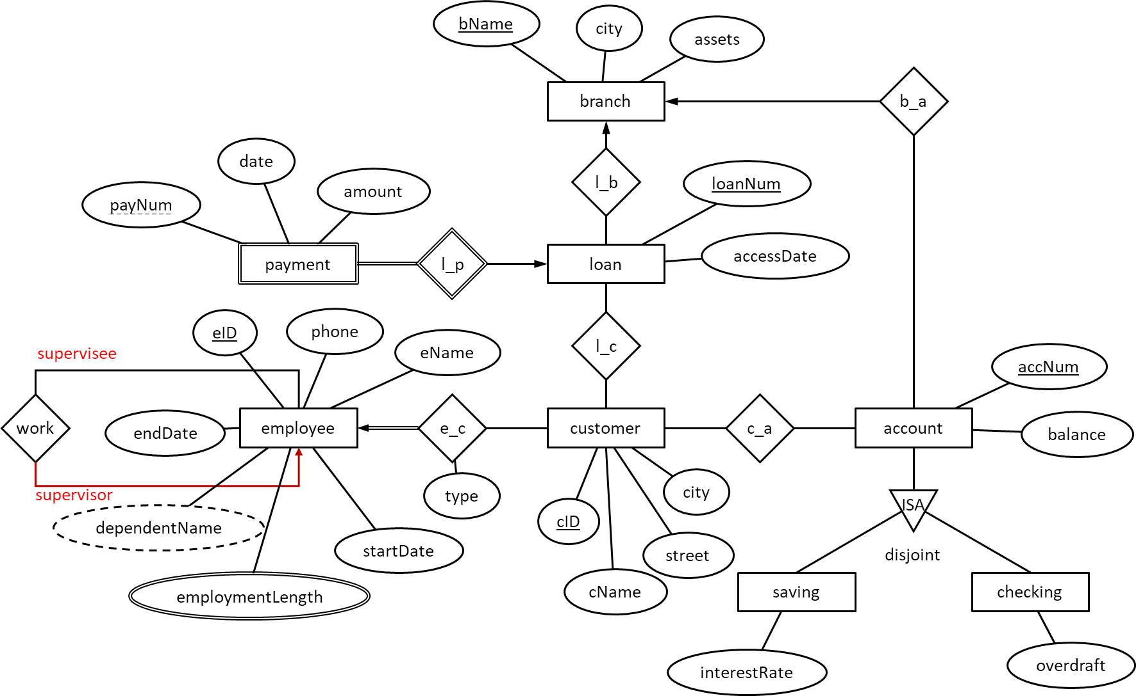Q1. Convert the following ER diagram into logical schemas. (30pt)

The schema of a database for public transportation companies is as follows. Keys are underlined.



$company=(\underline{cID},cname,address,phone)$

$route=(\underline{rID},departure,arrival,cID)$

// $cID$ is a foreign key to $company.cID$.



$vehicle=(\underline{plateNum},model,capacity,manufacturer,cID)$

// $cID$ is a foreign key to $company.cID$.

$driver=(\underline{dID},name, gender,age,cID)$

// $cID$ is a foreign key to $company.cID$.

$serve=(\underline{rID,plateNum})$

// $rID$ is a foreign key to $route.rID$.

// $plateNum$ is a foreign key to $vehicle.plateNum$.

$drive=(\underline{plateNum},dID)$

// $dID$ is a foreign key to $diver.dID$.

// $plateNum$ is a foreign key to $vehicle.plateNum$.

Q2. Write a query for each following question. Assuming students’ name and instructors’ name are unique. (10pt for each)

1. Find the number of vehicles owned by “Xinhe” (company name).
2. Find the companies who owns more than 10 vehicles. Show the company names and number of vehicles owned by each.
3. Find the route which is served by more vehicles than other routes. Show the departure and the arrival of the route.
4. A driver retires at age 65 for males or at age 60 for females. Remove retired drivers from the database.
5. The company “ZhuhaiGongjiao” (company name) opens a new route from “UIC” (departure) to “Gongbei” (destination). The company will assign any vehicle manufactured by “BYD” to the new route. Add correct records to the database.

Q3. Implement the above logical design in SQL. You need to select suitable data types and link foreign keys properly. (10 pt)

Q4. The above schema is converted from an ER diagram which has $company$, $route$, $vechile$, and $driver$ as entity sets; $serve$ and $drive$ as relationship sets. What are the constraints on the two relationship sets? (10 pt)